

**Program :**B.tech(CSE)

**Course Title :**AI Assisted Coding

**Course Code :**24CS002PC215

**Semester :**3rd sem

**Name of Student :**Kaveti Manohar

**En. No. :**2403A52079

**Batch No. :**02

**Date :**20/08/2025

#LAB ASSIGNMENT-3

Task Description -1:

Try 3 different prompts to generate a factorial function.

Prompt-1

* Write a python function to find the factorial of a number using recursion.

Question:

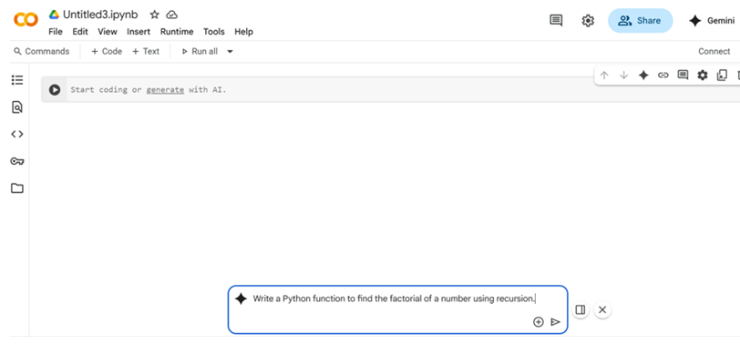

Code:

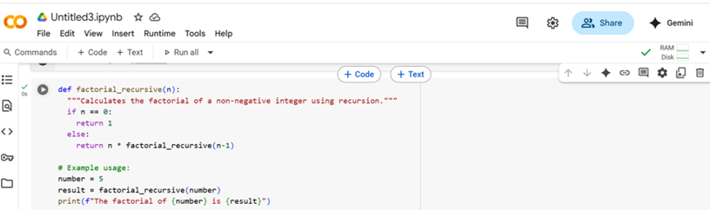

Output:

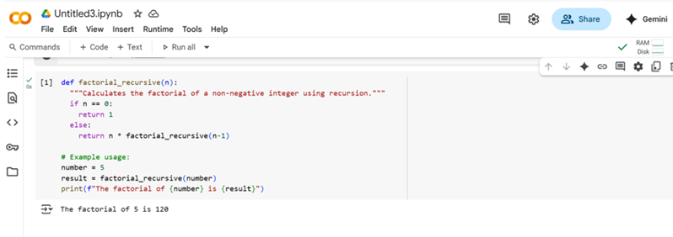

Prompt-2:

* Write a python function that calculates factorial to find the factorial of a number.

Question:

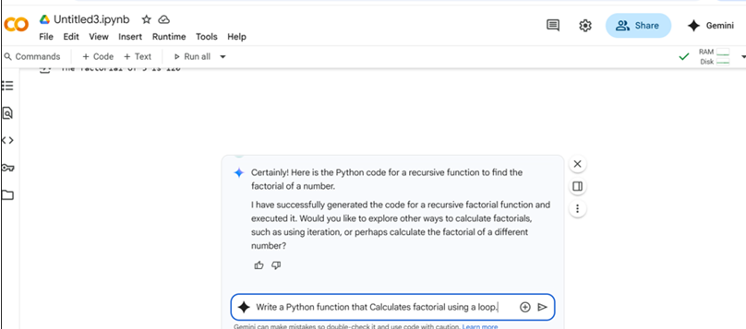

Code:

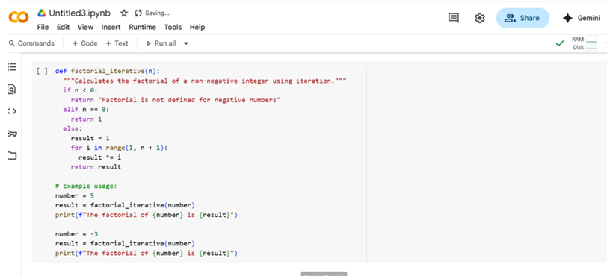

Output:

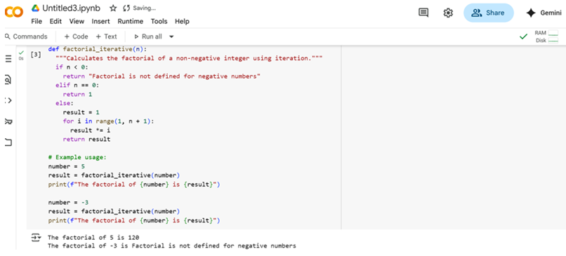

Prompt-3:

* Write a python function() that returns the n!

Question:

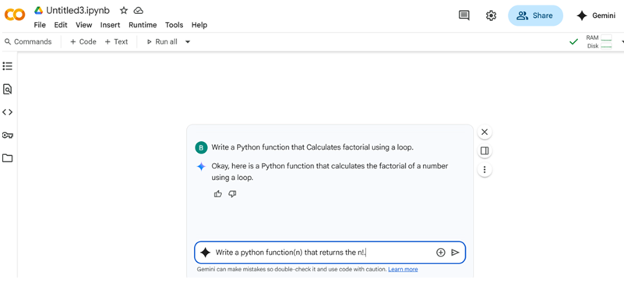

Code:

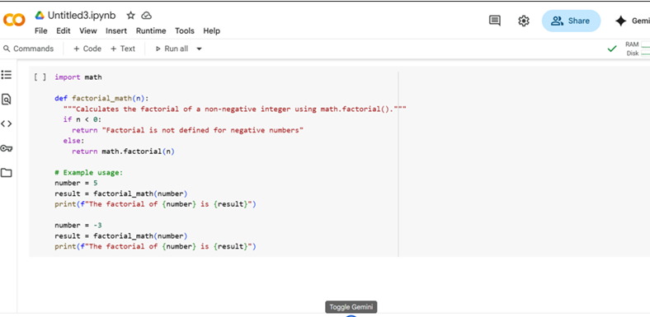

Output:

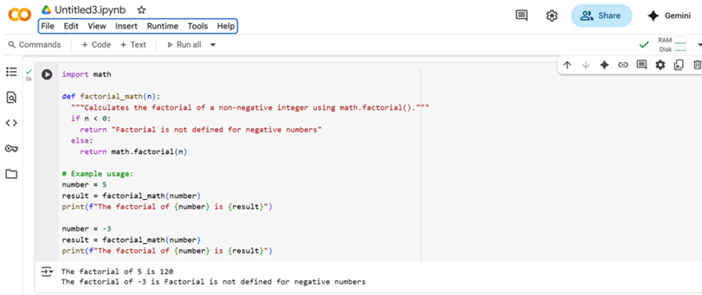

Tas Description-2

* Provide a clear example input-output prompt to generate a sorting function.

Prompt-2

* Write a python program using python built-in math.factorial() function

Question-

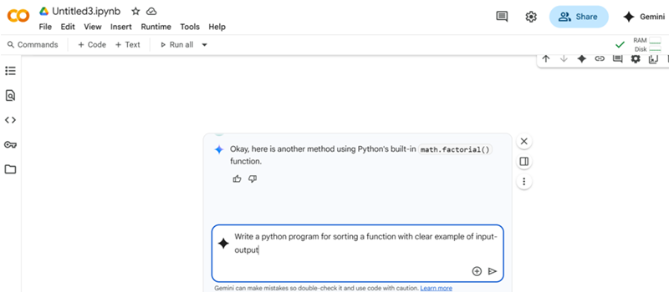

Code-

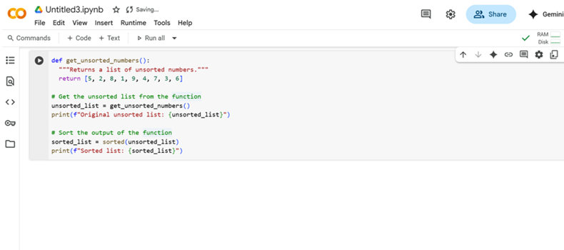

Output-

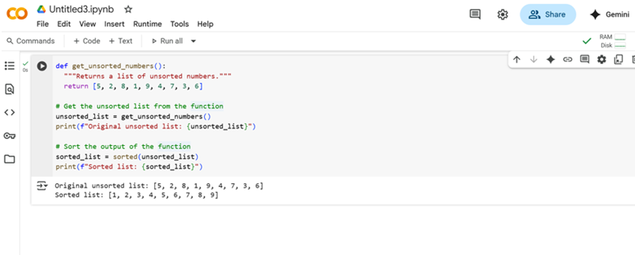

Task Description-3:

* Start with the vague prompt “Generate python code to calculate power bill” and improve it step-by-step.

Prompt-

* Write a python function to calculate power bill based on units consumed.

Question-

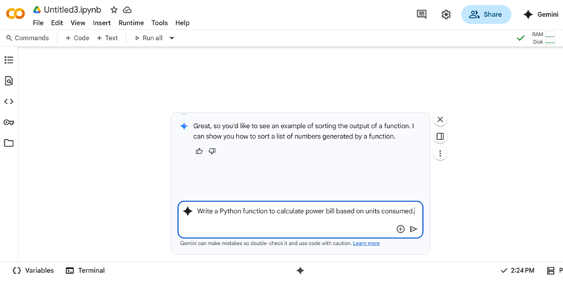

Code-

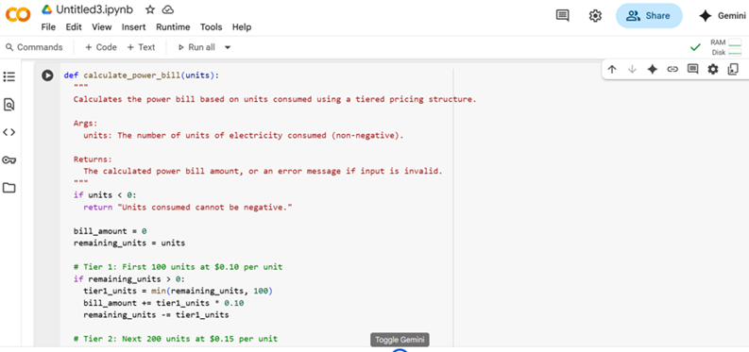

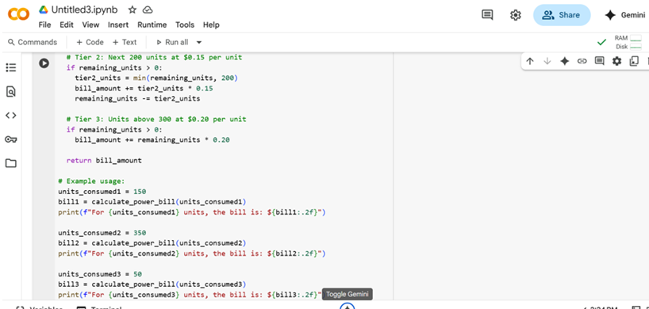

Output-

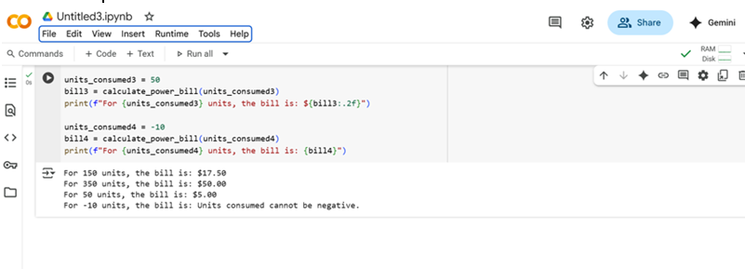

Task Description-4:

* Write structured comments to help AI generate two linked functions (e.g., login_user() and register_user()).

Prompt-4

* Write Python code with comments to create two functions :register user() to save username and password ,and login_user() to check if login details are correct.

Question-

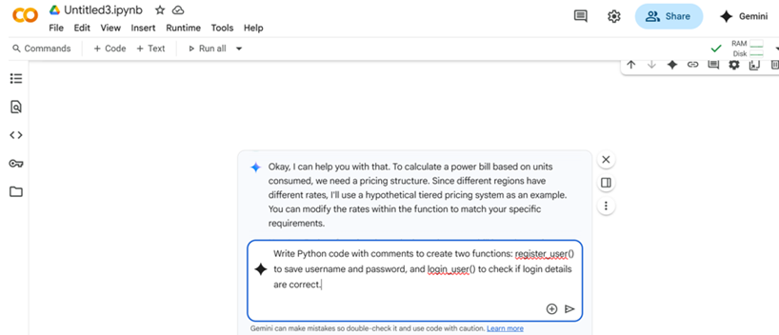

Code-

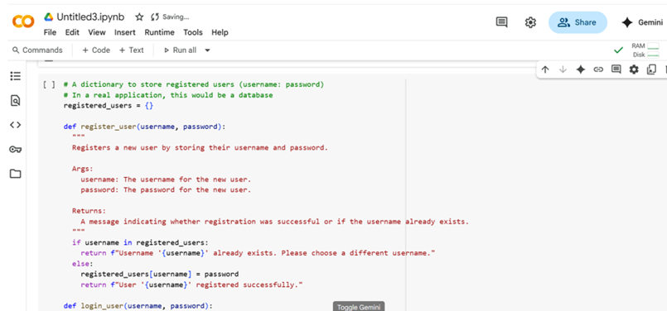

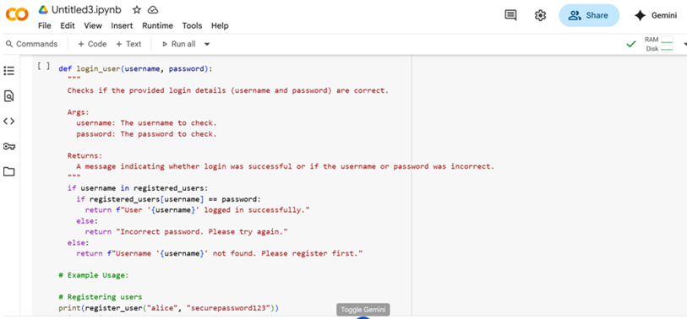

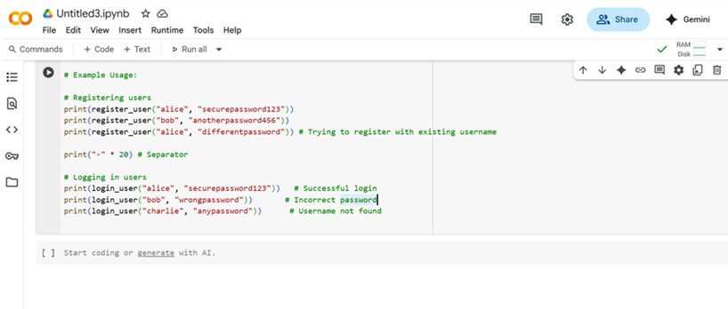

Output-

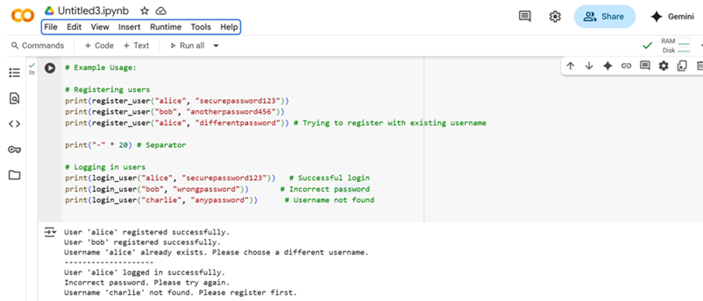

Task Description-5:

* Analyzing Prompt Specificity: Improving Temperature Conversion Function with Clear Instructions.

Prompt-5

* Write a function with comments to convert temperature between Celsius and Fahrenheit.

Question-

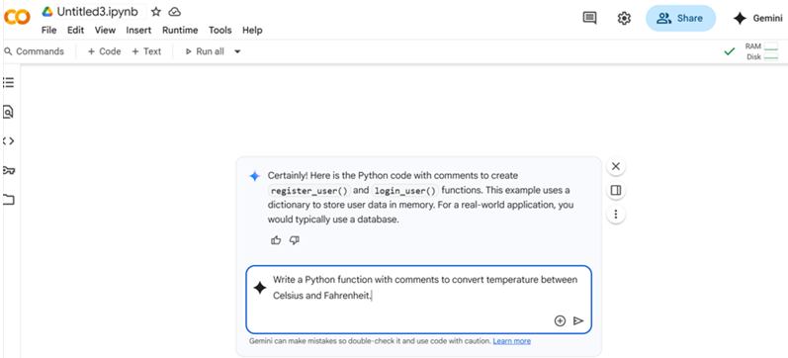

Code-

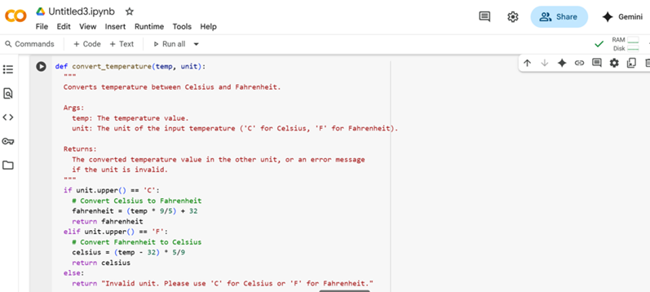

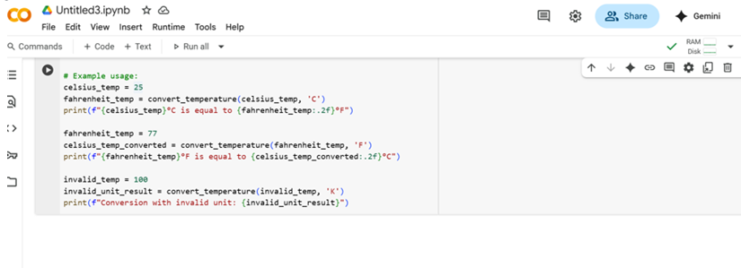

Output-

